Successful business performance delivers record year for CHG-MERIDIAN

- Growth: Lease originations up 22 percent year-on-year
- Internationalization: Successful acquisition of Australian technology specialist equigroup in 2018
- Circular economy: Further increase in the number of refurbished and data-erased assets for the secondary market

Weingarten, April 9, 2019

The international CHG-MERIDIAN Group can look back on a very successful year. The independent provider of technology management and financing increased in 2018 its volume of lease originations by 22 percent to €1.511 billion (2017: €1.244 billion). Profit from ordinary activities (before taxes) amounted to €95 million, which was 9 percent above the prior-year figure (2017: €87 million). At €66 million, net income (after taxes) rose by just under 15 percent (2017: €57 million).
"The continuing digital transformation of our customers' businesses enabled us to maintain our high level of growth and led to new record results in 2018, while our geographical and technological diversification is paying off. This also leaves us very well positioned for future growth," says Dr. Mathias Wagner, Chairman of the Board of Management of the CHG-MERIDIAN Group.

Organic growth of 15 percent was one of the main factors in the record volume of lease originations. This was generated in a range of markets and marks a continuation of the successful business strategy. International lease originations accounted for around 52 per cent of the total. The sectors of industrial technology and healthcare technology, currently undergoing a process of expansion and internationalization, performed well. In 2018, they made a positive contribution of around 20 percent to the volume of leases originated by the CHG-MERIDIAN Group.

Further internationalization through equigroup acquisition

In September 2018, CHG-MERIDIAN acquired the technology management specialist equigroup (HQ: Sydney, Australia). The inclusion of the company in the Group’s consolidated accounts for four months of that year contributed further to CHG-MERIDIAN’s growth.

“The acquisition of equigroup was a further significant element of CHG-MERIDIAN’s growth strategy. It gave us access to a growing and very attractive economic region and also strengthened our market position in western and northern Europe,” explained Wagner.

Number of refurbished assets for the secondary market continues to rise

The number of remarketed assets also increased in 2018. Overall, around 690,000 IT devices, the highest number so far, were professionally refurbished for the secondary market across the Group. CHG-MERIDIAN’s own technology and service centers in Gross-Gerau (Germany) and Skien (Norway) remarketed around 552,000 devices. As one of the leading remarketers of IT assets in Europe, CHG-MERIDIAN has for a long time made a valuable contribution to sustainability and an efficient circular economy in which resources are used efficiently.

Professional data erasure for IT assets continued to be a sustainable engine of growth in 2018. The number of devices that underwent erasure rose to around 213.000 units across the Group. Of these, around 168,000 devices underwent certified erasure at CHG-MERIDIAN’s own technology and service centers.

“Companies are becoming increasingly aware of the importance of data protection and data security and our certified eraSURE® service is ideally positioned to cater to this trend, which is why it is a key component of our solution portfolio throughout the entire IT lifecycle,” says Wagner.

Digitalization initiatives: Optimistic outlook for 2019

In addition to further internationalization, CHG-MERIDIAN is also focusing strongly on digitalization. In particular, CHG MERIDIAN supports its customers with a complete range of services relating to the digital workplace over the entire technology lifecycle, thereby offering added value in the context of complex – often international – digitalization processes.

Against this background, CHG-MERIDIAN is confident that it can sustain its path of dynamic growth in 2019. “A large number of customer projects, along with the implementation of our own digital strategy, have allowed us to build up valuable expertise, which as a independent provider we are making available to our clients. We offer an external view to support them in implementing their digitalization projects, and also provide bespoke funding and efficient technology management,” Wagner explained.

Further information can be found at:
www.chg-meridian.com

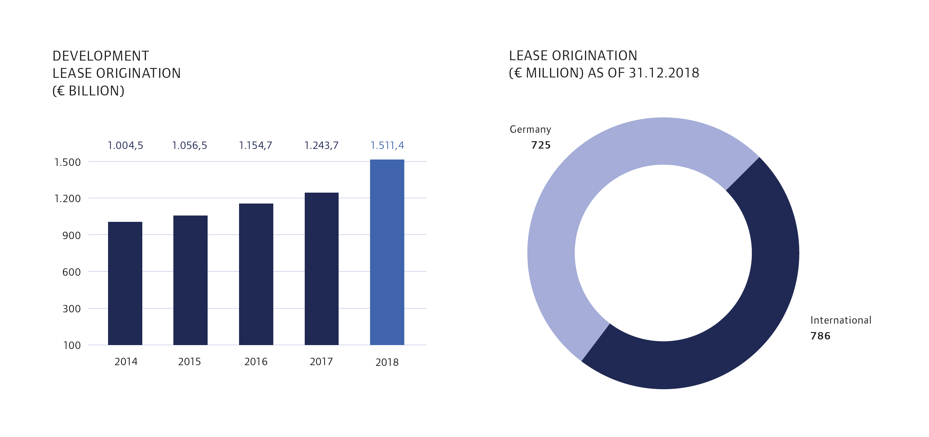

The CHG-MERIDIAN Group

The CHG-MERIDIAN Group is one of the world’s leading non-captive providers of technology management services to the IT, industrial, and healthcare sectors. With some 1,000 employees, the CHG-MERIDIAN Group offers its customers comprehensive support for their technology infrastructure – from consulting, financial, and operational services to used-equipment remarketing services through its two technology and service centers in Germany and Norway.

The CHG-MERIDIAN Group provides efficient technology management for large and medium-sized companies as well as public-sector clients. It now serves more than 10,000 customers worldwide, managing technology investments worth a total of over €6.13 billion. The online-based TESMA® Technology and Service Management System provides more than 15,000 users with maximum transparency in technology management. The CHG-MERIDIAN Group has offices in 25 countries across the globe. Its headquarters are in Weingarten, Germany.

Efficient Technology Management®

